**Extrair texto do Twitter**

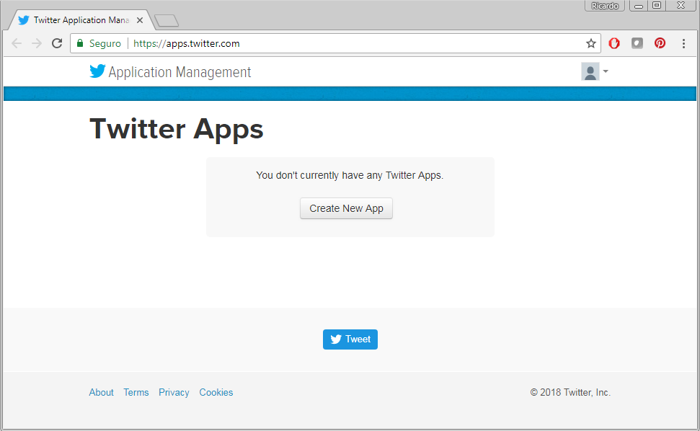

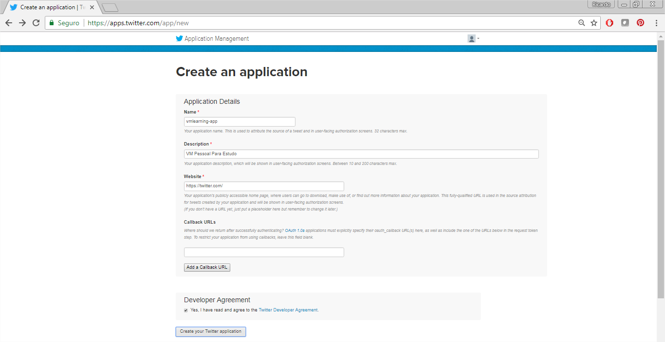

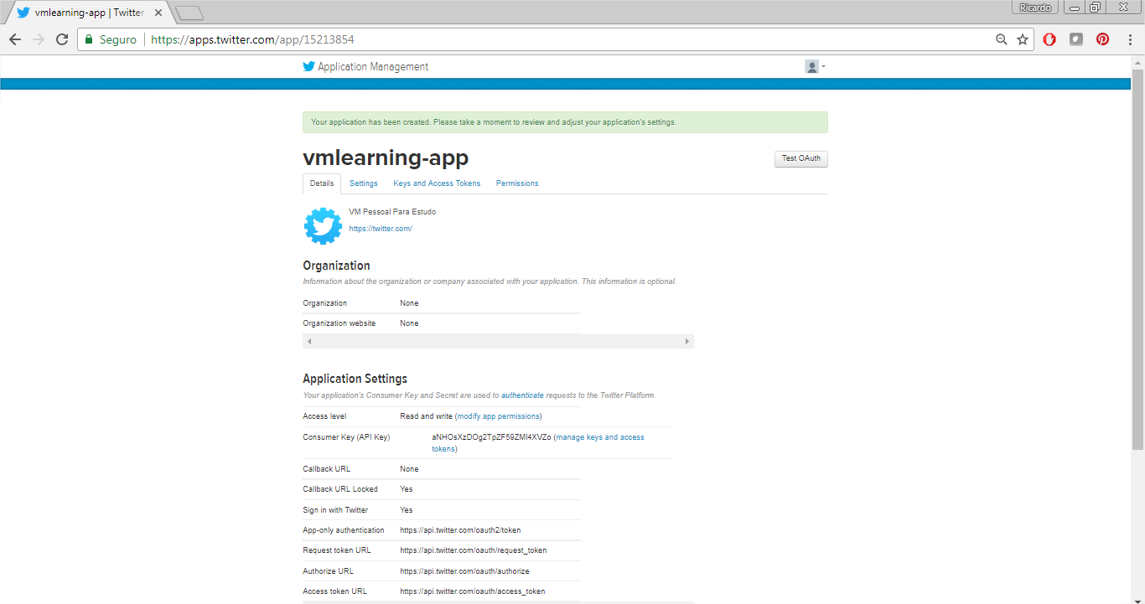

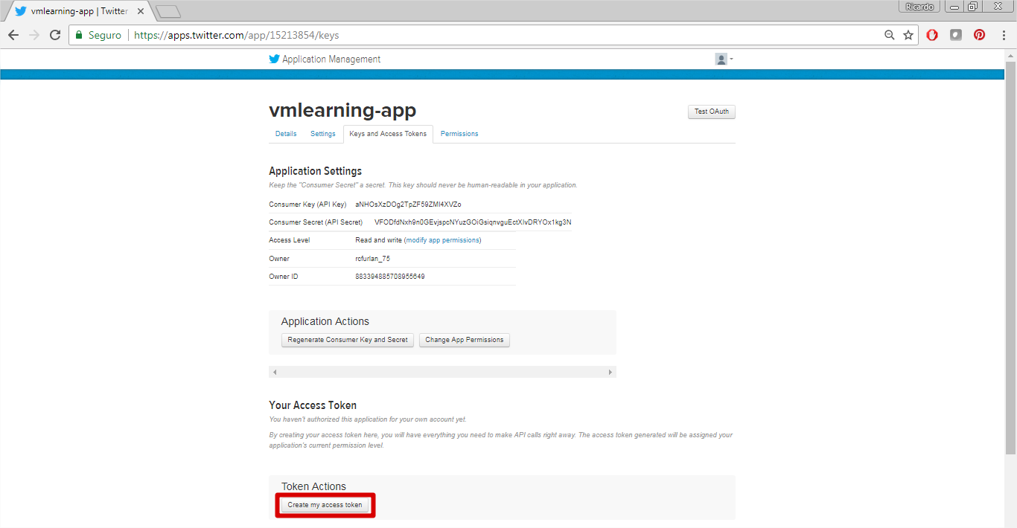

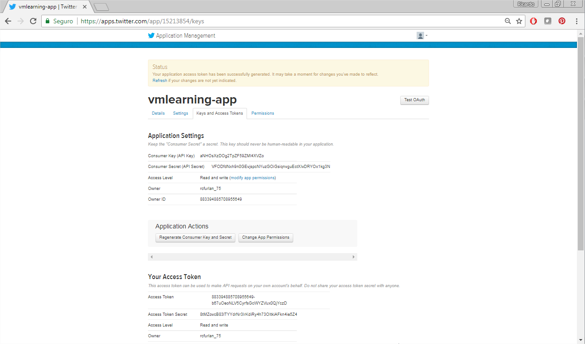

Application Settings

*Keep the "Consumer Secret" a secret. This key should never be human-readable in your application.*

Consumer Key (API Key) aNHOsXzDOg2TpZF59ZMl4XVZo

Consumer Secret (API Secret) VFODfdNxh9n0GEvjspcNYuzGOiGsiqnvguEctXIvDRYOx1kg3N

Access Level Read and write ([modify app permissions](https://apps.twitter.com/app/15213854/permissions))

Owner rcfurlan_75

Owner ID 883394885708955649

Your Access Token

*This access token can be used to make API requests on your own account's behalf. Do not share your access token secret with anyone.*

Access Token 883394885708955649-b67uOeoNLV5CyrfsGcWYZVux0QjYczD

Access Token Secret 8tMZovcB83lTYYdrNr3IrKdiRy4h73OItkiAFkn4ie5Z4

Access Level Read and write

Owner rcfurlan_75

Owner ID883394885708955649

**Instalando bibliotecas Python do Twitter**

